Zenworks for Desktops Remote Control Policy

Setup and Configuration of Remote Control Policy

Remote Control Policy at DSC is enabled through the ‘DSC Workstation Policy Package’ in the DSC container. This policy is associated with the ‘workstation.dsc adm.dcccd’ container and the ‘workstations.training.dsc.adm.dcccd’ container, and affects all workstations in those containers. Workstations must have the Zenworks for Desktops 4 Agent with the Remote Management feature installed to use Remote Control. The remote control settings for the Workstation Policy Package are shown below:

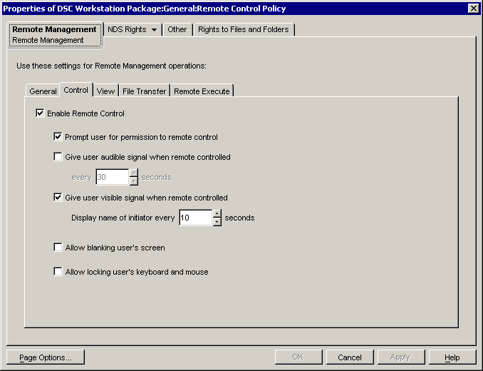

DSC Help Desk users are given rights to remote control or remote view workstations by granting the Help Desk Group the following rights to the Workstation container and all workstations in that container:
Remote Control-“Write”
ZEN Remote View-“Write”
Network Address-“Read”

These rights are assigned through the Remote Operator Wizard. To use the wizard, in Console One highlight the workstation container and select Tools >>Manage Remote Operator.
These rights can also be assigned in Console One to an individual workstation or to a container without using the Remote Operator Wizard.

The workstation must have the Zenworks agent, including the Remote Control component, installed to be remotely controlled.
Anyone who has Admin rights in a container also has Remote Control rights in that container. Admin level users can also change Remote Control Policy and Remote Control settings on individual users and workstations.

Using Remote Control / Remote View

The workstation can be remote controlled from Console One through the NDS Workstation object, (right click and select Action>>Remote Control) or from the User object of the user who is logged in, (right click and select Remote Management) shown below:

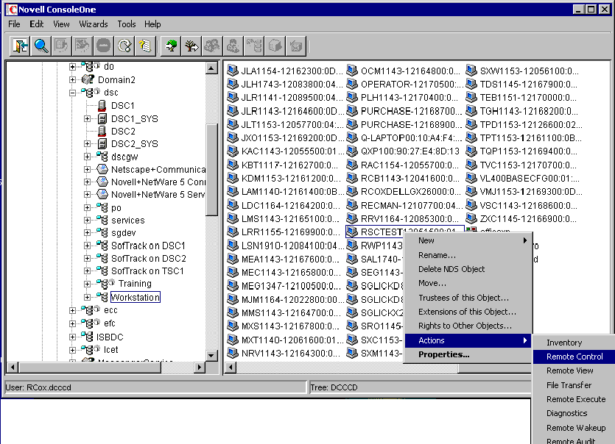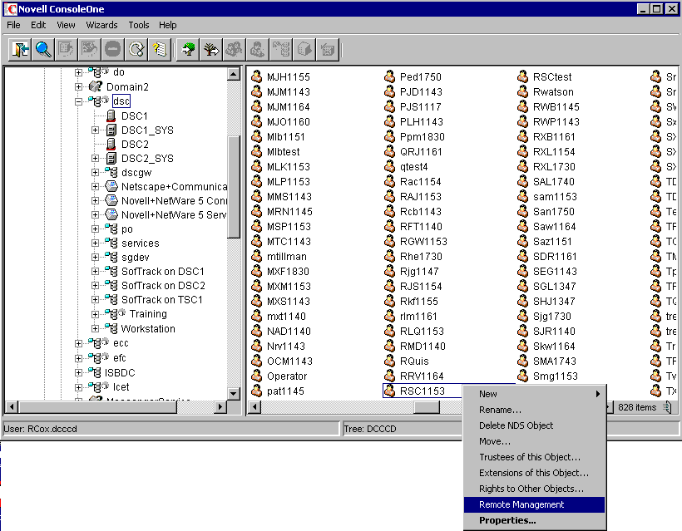

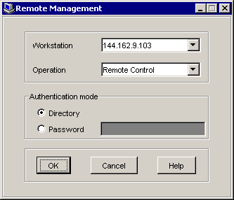
If the remote connection is made through the user object, the Help Desk user will see the box shown above, asking which workstation to connect to. All workstations the user is logged in to will appear in the pull-down menu. If the user is only logged in to one workstation, then only that one will appear.

The remote user is prompted with a pop-up box that asks if he will allow his workstation to be remotely controlled, and the name of the Help Desk person requesting permission.

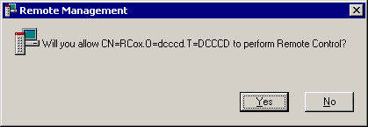
While being controlled, a “Remote Controlled By… “ icon appears on the desktop of the workstation.

Preventing Remote Control / Remote View

Remote Control and Remote View can be prevented for individual users who may require higher security, or on certain workstations. On the Remote Management tab of the NDS user or workstation object properties there is a checkbox for “Use these settings and ignore Remote Management Policy.” This overrides any other policy that may allow remote Control. If this is applied to an individual user it prevents Remote Control on any workstation while that user is logged in.

To prevent remote Control for a group of users, the “DSC No Remote Control User Policy” is set up to prevent Remote Control when associated users are logged in on a workstation.

Novell Documentation

For more information, planning and implementing remote management is discussed extensively in these Novell documents:
http://www.novell.com/documentation/zenworks65/pdfdoc/dmadmin/06_dmadmin_remmgmt.pdf

http://www.novell.com/coolsolutions/zenworks/feature_remote_security.html

Go to support.novell. com and search for “zenworks remote control” to find more articles on the subject.

