

Migrating the Webroot Admin Console from DBISAM to SQL Server Express 2005

Webroot Spy Sweeper Enterprise

Webroot Software, Inc.
2560 55th Street, Boulder, CO 80301
Toll Free: 800.870.8102 option 2
Email: esupport@webroot.com
www.webroot.com

As of version 3.0, DBISAM was no longer a supported platform for fresh Admin Console installations. The upcoming release will no longer support DBISAM as a database upgrade. It will be necessary to migrate your DBISAM installation to SQL Server before upgrading to version 3.5 (to be released this summer). Supported database platforms moving forward are SQL Server 2000 SP4, SQL Server 2005 or SQL Server Express 2005.

Before uninstalling your existing Admin Console, please be sure to have your keycode as you will need it on the installation of the admin console. The keycode can be found under Administration > Configuration > System Settings > Basic.

1. Close the Webroot Admin Console and stop the Webroot services (Webroot Admin Console, Webroot Client Service, and Webroot Update Service) on your server.

2. Go to [drive letter]:\Program Files\Webroot\Enterprise\Server and copy the DB folder to a different location on your server (not located under the Webroot directory).

3. Uninstall the SpySweeper Client first if it is installed on the server.

3a) Open a command prompt
3b) Change directories to [drive letter]:\Program Files\Webroot\Enterprise\Server\Client
3c) Type exactly as shown here: ssecleanup -Remove

4. Uninstall the Webroot Enterprise Server through Add/Remove Programs. After uninstalling, verify that the Webroot folder no longer exists in the directory structure as well as in the registry (HKLM/Software).

5. After the original install using DBISAM not longer exists, it will now be necessary to install and point to Microsoft SQL Server Express 2005.

Note: if you have SQL Server 2000 SP4 or SQL Server 2005, this can be used instead of SQL Server Express.

6. Download the 3.1.0.1844 Spy Sweeper Enterprise installation from the link below.

http://www.webroot.com/entcenter/downloads/3.1patch/WebrootEnterpriseServerSetup.zip

7. Install the Webroot Admin Console using SQL Server. The instructions below will demonstrate an installation with SQL Server Express 2005.

7a) After extracting the package above, please run WebrootEnterpriseServerSetup.exe. Please click Next at the Welcome screen (shown below).

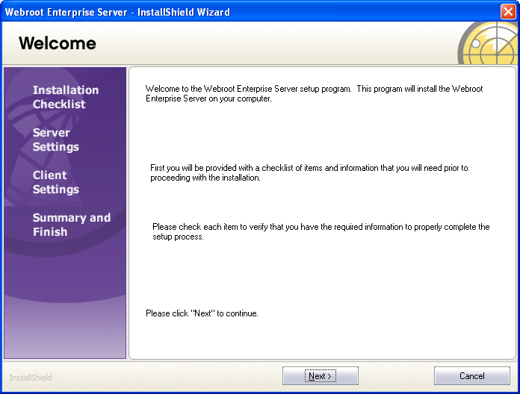

7b) Accept the license agreement and select Next (shown below).

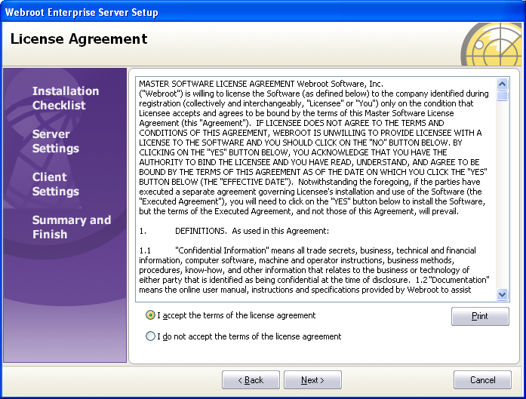

7c) Verify the Installation Checklist. MDAC 2.8 is a requirement. The installation will prompt you to install MDAC 2.8 if it is not currently installed. If using SQL Server 2000 or SQL Server 2005, please select the second radio button under “Database Platform”. Check all items and select Next.

NOTE: MDAC 2.8 can be found at:
http://www.microsoft.com/downloads/details.aspx?FamilyID=6C050FE3-C795-4B7D-B037-185D0506396C&displaylang=en

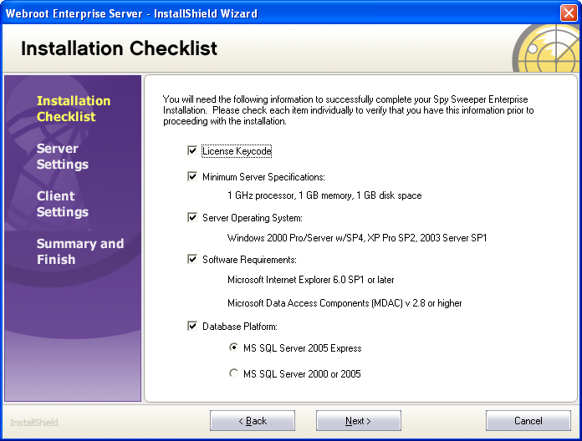

7d) The Prerequisites screen will display links to the Microsoft .NET framework as well as SQL Server Express 2005 if they are not detected on the machine. If shown, you will need to now install the .NET software followed by SQL Server Express.

NOTE: Links for the .NET framework and SQL Express are below:

Microsoft .NET Framework 2.0

http://www.microsoft.com/downloads/details.aspx?familyid=0856eacb-4362-4b0d-8edd-aab15c5e04f5&displaylang=en

Microsoft SQL Server Express 2005
http://www.microsoft.com/downloads/details.aspx?familyid=220549b5-0b07-4448-8848-dcc397514b41&displaylang=en
*** For a detailed description on installing Microsoft SQL Server 2005 Express for use with Webroot Enterprise Spy Sweeper, please follow the instructions in Appendix A. ***

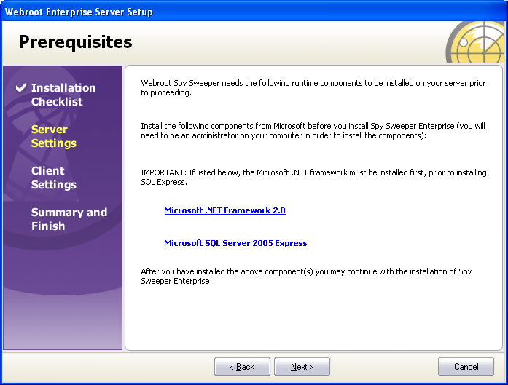

7e) After installing SQL Server Express, please click Next to continue with the Spy Sweeper installation.

Detailed instructions on the installation can be found in the System Administrator’s Guide (link below) in the section titled “Installing Webroot Enterprise Server on Your Company Server on page 13.

http://download.webroot.com/WebrootEnterprise1844SAG.zip

8) After the installation of the Webroot Admin Console has completed, you can now begin the migration from DBISAM to SQL Server.

Detailed instructions on the migration can be found in the System Administrator’s Guide (link provided in Step 7e) in Appendix B: Migrating an Existing Installation from DBISAM to SQL Server.

9) After running the migration to SQL Server, you can now reinstall the Webroot Spy Sweeper client (if uninstalled in Step 3).

The Management Studio for Microsoft SQL Server Express 2005 can be found at the link below:

http://webrootenterprise.supportportal.com/Portal/Kb/ArticleView.aspx?implID=232845&ObjectId=207

Please contact Enterprise Technical Support with any questions on the migration.

Phone: 800-870-8102 option 2
Email: esupport@webroot.com
Web: http://www.webroot.com/business/support/ticket.html

Appendix A: Installing SQL Server Express 2005 for Webroot Enterprise Spy Sweeper

1. After downloading and extracting the files for Microsoft SQL Server Express 2005, the EULA will launch. Accept the license agreement and select Next.
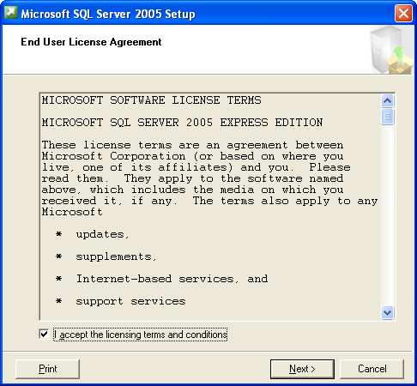

2. The Installing Prerequisites screen will then be displayed. Click Install.

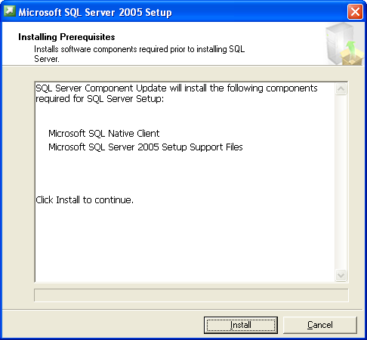

3. After the prerequisites are installed successfully, click Next.

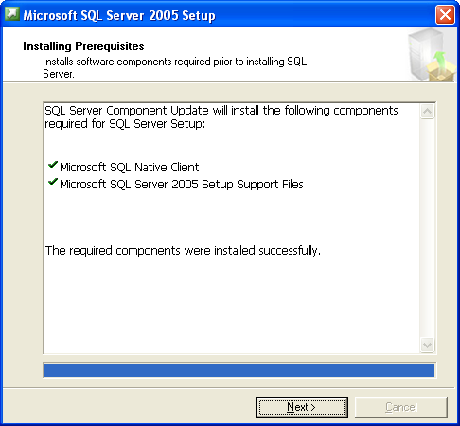

4. The installation Wizard should now launch. Select Next.
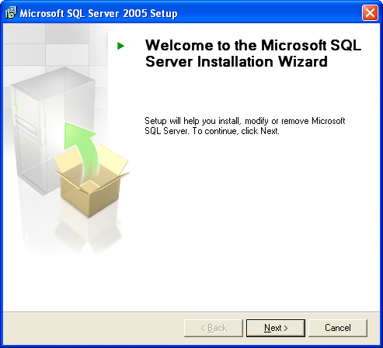

5. The Installation will now perform a System Configuration Check. When completed, select Next if there were no errors.
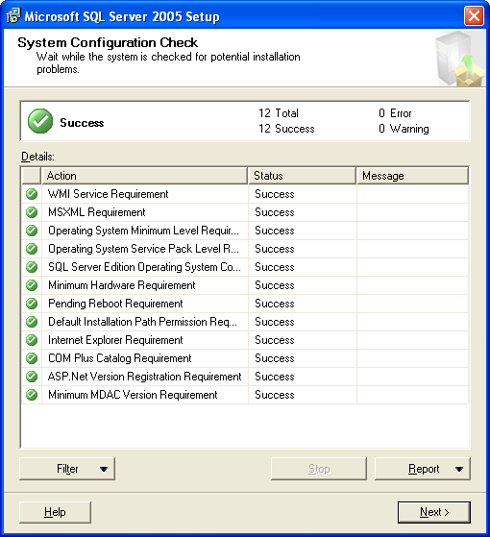

6. The Registration Information screen will now display. Please enter your Name and Company information. Select Next.
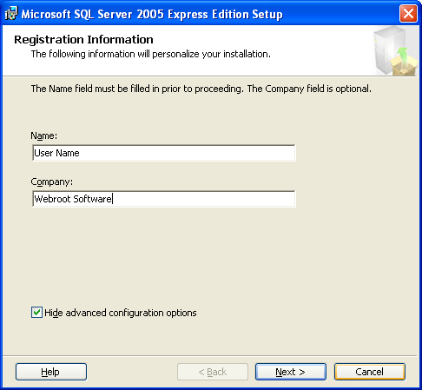

7. If desired, the installation path can be modified on the Feature Selection screen. Otherwise, select Next.
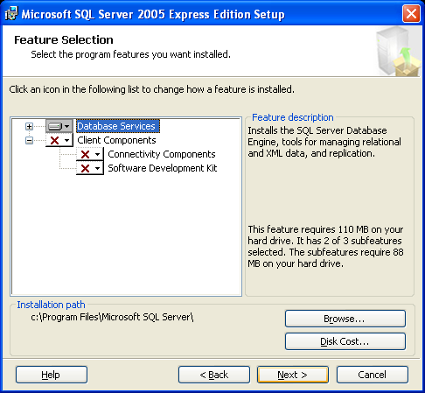

8. Select “Mixed Mode” for the Authentication Mode. Enter a password to be used with the SA logon. This password will later be required for the Webroot Admin Console installation.
NOTE: Mixed Mode is required for SQL Server to work properly with Webroot Enterprise Spy Sweeper.
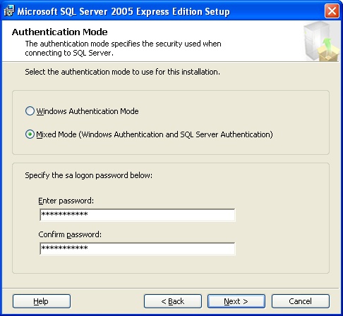

9. Select the options desired for the Error and Usage Report Settings. Select Next.
NOTE: These settings are not required to function with Webroot Spy Sweeper Enterprise.
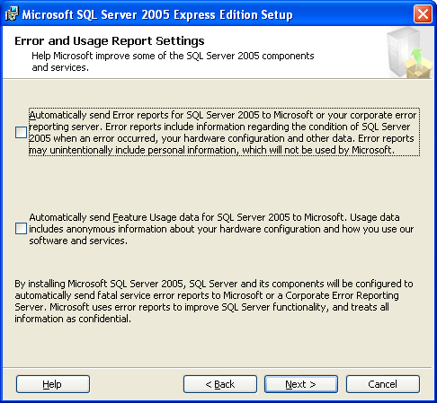

10. Select Install at the “Ready to Install” screen.
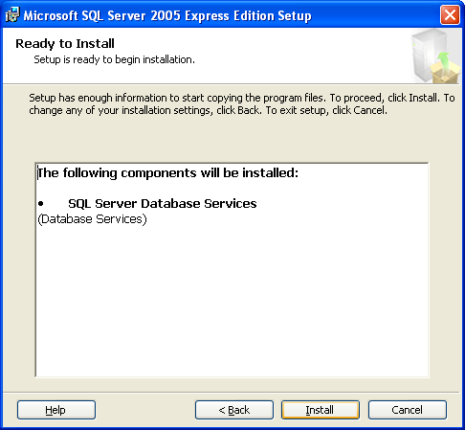

11. After selecting to install, a screen will appear showing the “Setup Progress”. Click Next once setup has finished for all components.
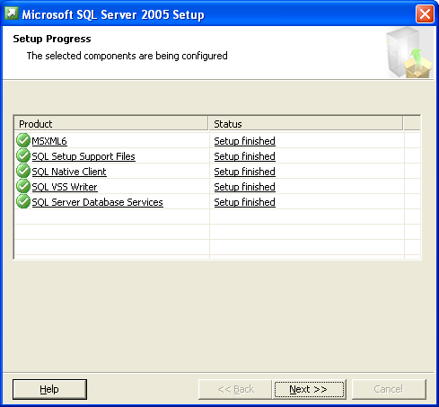

12. Once the setup has finished, the “Completing Microsoft SQL Server 2005 Setup” screen will appear. Select Finish.
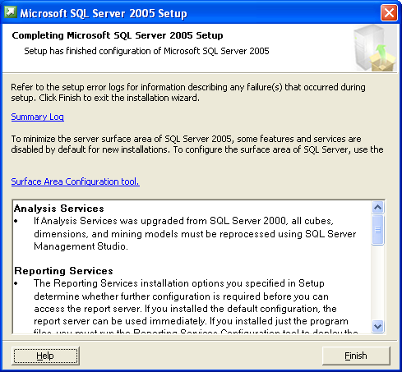

After SQL Server Express has been installed, please go back to Step 7e.

