Installing the iHeat Windows Client

The user will need to log in to the ADM domain to access iHeat

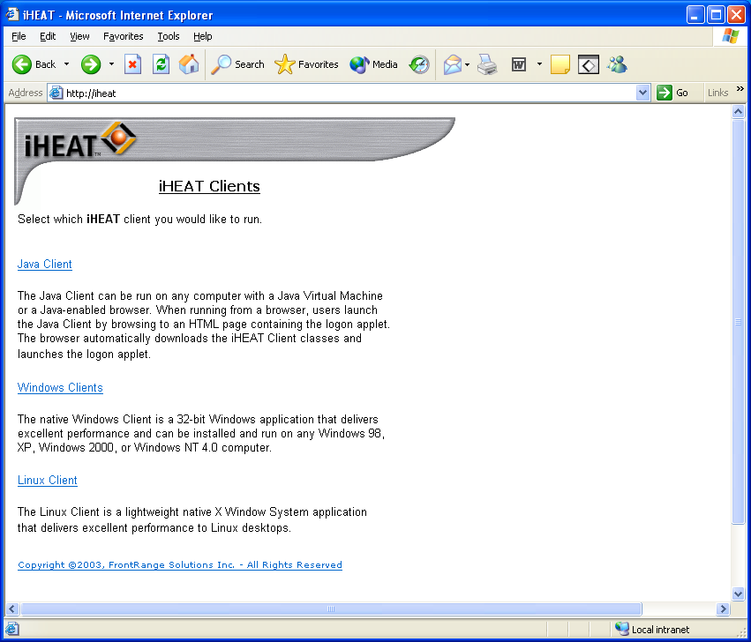

In Internet Explorer go to https://iheat or https://iheat.dcccd.edu

In the iHeat Clients window, shown above, select Windows Client

In the next Window, titled ‘Windows Clients,’ (not shown) select ‘Native Windows Client’

In the ‘Installing iHeat…’ window, shown above, click to download the iHeat Windows Client
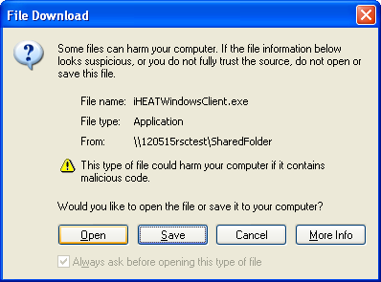
In the File Download window above, select ‘Open’ to run the install from the server. This will take several seconds to react.

Take all of the default settings in the client installation. This will add an iHeat Windows Client icon to your desktop.
Click on the ‘iHeat Windows Client’ icon on your desktop

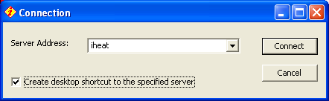
In the Connection box shown above, for Server Address type iheat and check the “Create desktop shortcut to the specified server” box, click ‘Connect’

This is the ADM Domain Login box. Log in with your ADM domain ID and password, usually the same as you Novell network login ID. Not all users will get this login box.
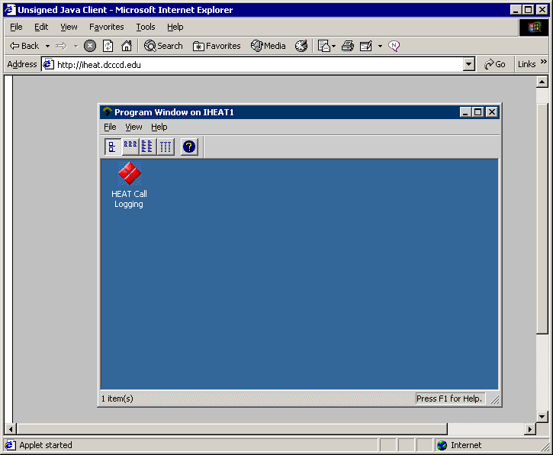
Click on the Heat Call Logging icon

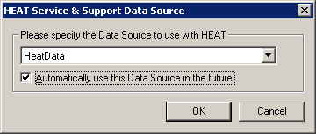
At the “Heat service and Support Data Source” box select ‘HeatData’ and check the box for “Automatically use this Data Source in the Future.”
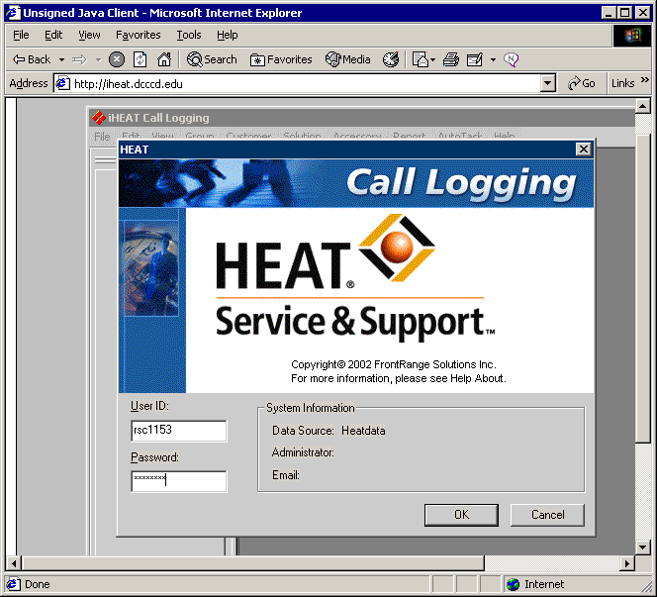

This is the Heat Login. Use the same Login name as your ADM domain login.
Your default Heat password is ‘heat’
Not all users will get this login screen. Heat will log them in automatically using their ADM user ID.

Do not exit by closing Internet Explorer!
Be sure to exit Heat by selecting ‘File’ ‘Exit’ at the Call Logging Window,

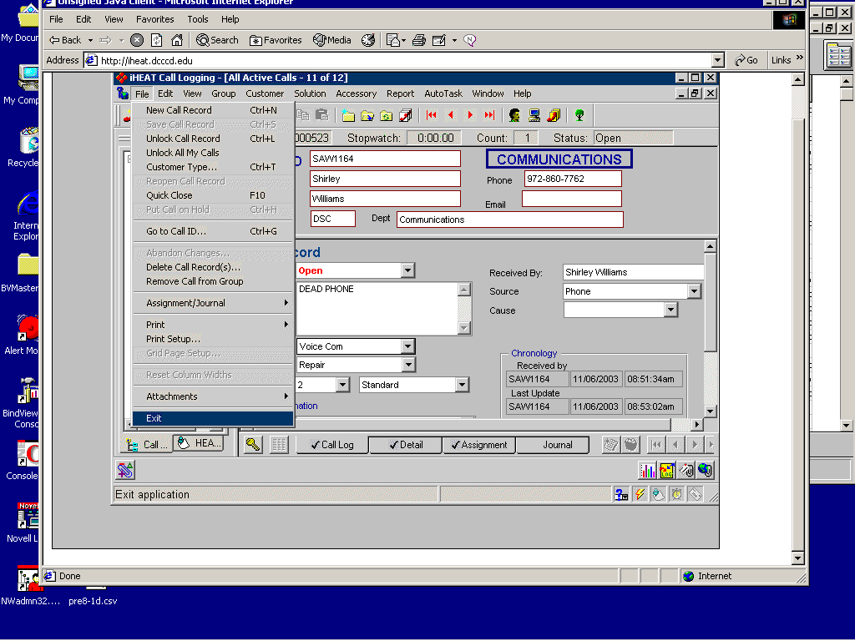

And select ‘File’ ‘Exit’ at the Program Window

