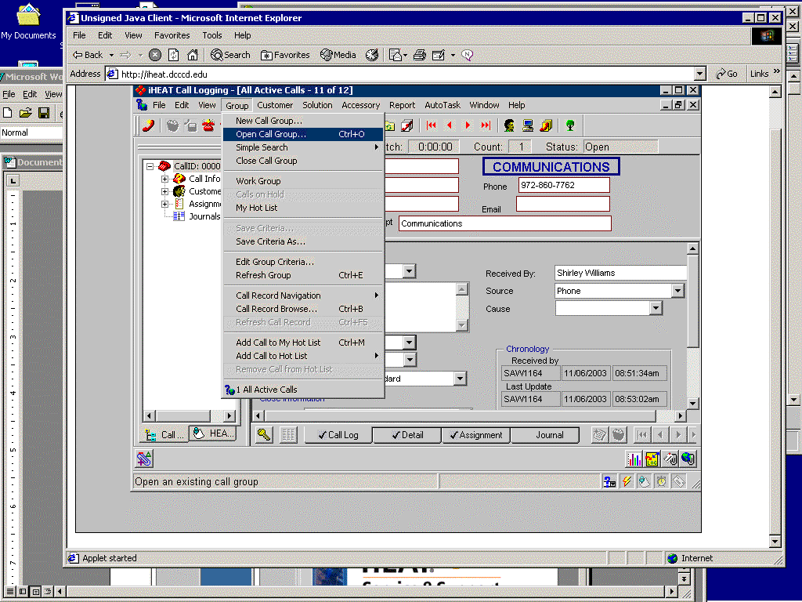
Choose which call group you want to see

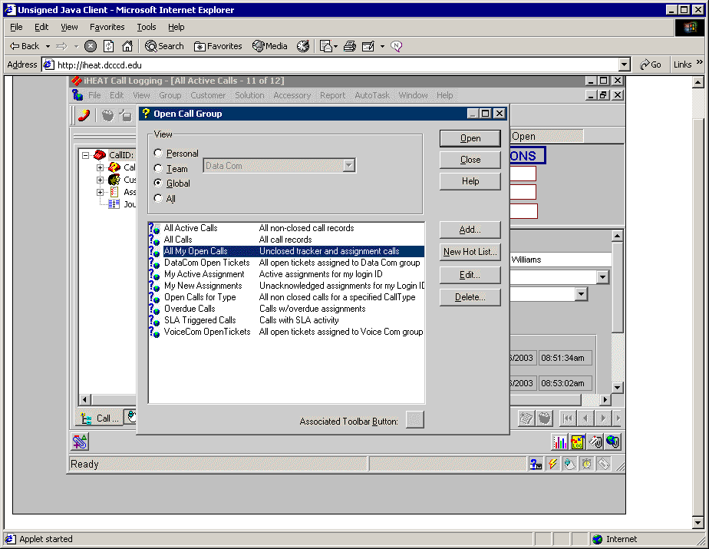
Choose the ‘Global’ button and ‘All Active Calls’ to start out

‘My Active Assignments’ will show calls assigned to the person who is logged in
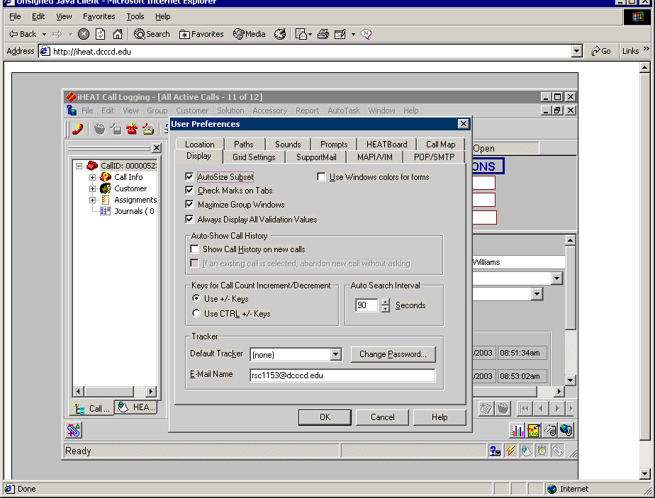
To reset the Heat password select ‘Edit’ and ‘User Preference’ If you reset the Heat password to match your ADM domain password you will only get one login screen instead of two
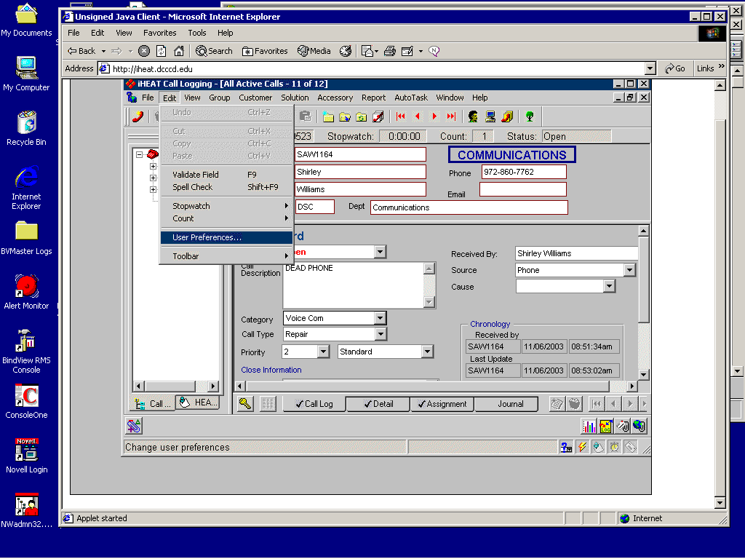
Click on the ‘Change Password’ button shown below

Do not exit by closing Internet Explorer!
Be sure to exit Heat by selecting ‘File’ ‘Exit’ at the Call Logging Window,

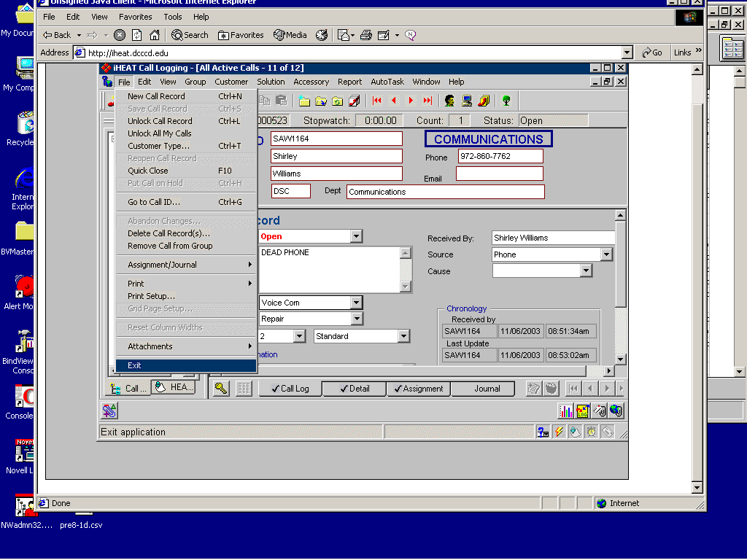

And select ‘File’ ‘Exit’ at the Program Window

