Using NAL App to remove PCs from Bindview Database

The NAL Applications BVDeleteXP and BVDelete98 are set to Force Run when the user’s NAL (Netware Application Launcher) starts. BVDeleteXP will remove the Bindview hidden files from a Win 2000 or XP PC. BVDelete98 removes the hidden files from Win9x PCs. Users must be running NAL on their PC to use either BVDelete.

- Run a Bindview grid that includes the field “User’s Network Login Name” and export the report to Excel. The “User’s Network Login Name” field is the Novell Login ID of the most recent person to run bvaudit on this PC.

- Remove the affected users from the BVInventory group in Console One.

- Add the users to the BVDelete group in Console One. This will force run the BVDeleteXP or BVDelete98 application when the user logs in. The users can be left in this group as long as needed. It will not be a problem if they run BVDelete several times.

- Delete the nodes from the Bindview database.

- When the Bindview hidden files have been removed from the user’s PC, remove the user from the BVDelete group and put them back in the BVInventory group.

BVDeleteXP NAL Application

This NAL application deletes the Bindview hidden files from a Windows 2000 or Windows XP PC.
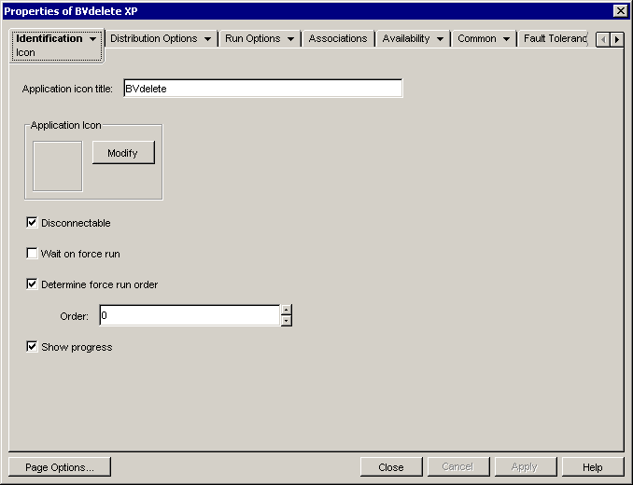

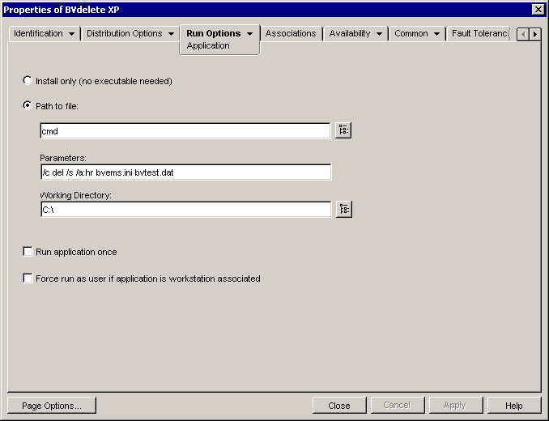
The CMD command works on Win 2000 or XP. For Win 9x the application would need to use command.com.
In the Parameters:
/c runs the command specified
del is the DOS delete command
/s deletes from all subdirectories
/a:hr deletes files with hidden and read-only attributes
bvems.ini and bvtest.dat specifies the files to be deleted

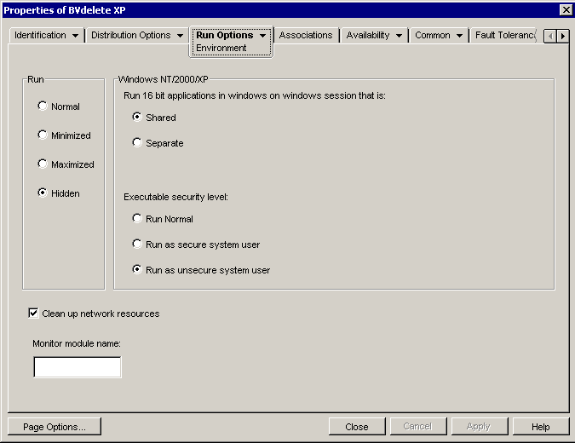
The important settings here are ‘Hidden’ and ‘Run as unsecure system user’
‘Run as unsecure system user’ allows the application to run on the PC regardless of the rights of the user who is logged in
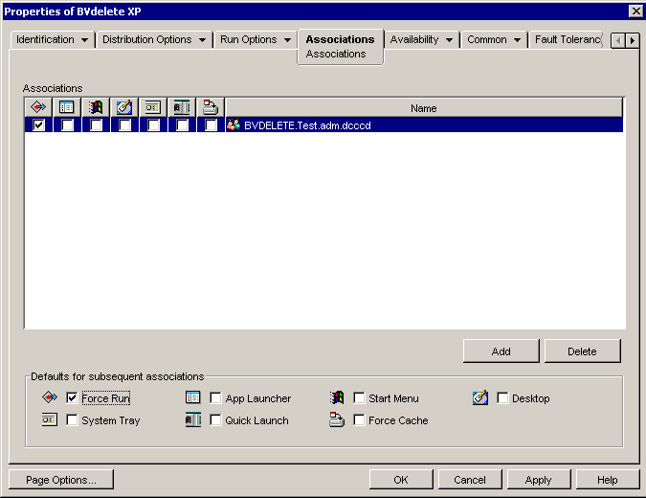
The users should be added to the BVDELETE group to run this application
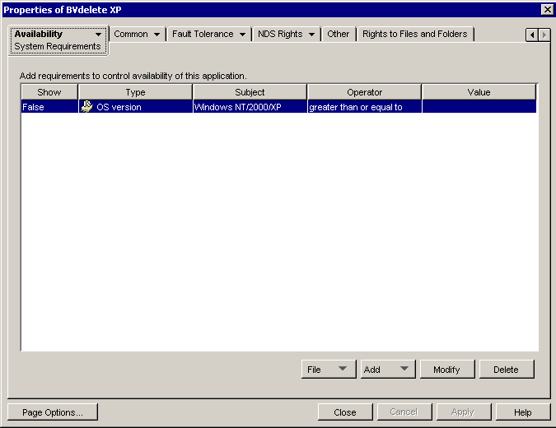
The ‘Force Run’ box should be checked
This setting allows the application to run only on NT/2000/XP, and not on Win 9x

