How to Map a Drive to the BVEMS Shared Folder

In Windows Explorer
Select Tools\ Map Network Drive
choose an unused drive letter, and in the Folder box type in \\dscbv1\bvems
check the “Reconnect at Login” box
Click on connect using a different login name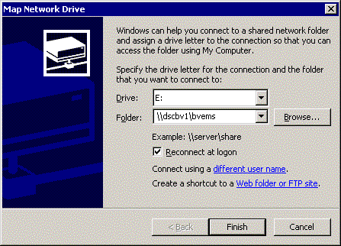.

Accounts in the ADM NT Domain are set up with your 3-letter 4-digit login ID.
Your password for the ADM domain may not be the same as your Novell password the first time that you log in.

The password might need to be reset on your first login

In the ‘User name:’ box, type in ADM for the domain name and your login ID as shown below

