This document should be used along with the “Quick Start for BVControl…” guides also available from the netsupport.dcccd.edu/bindview web page.

There are two major components of Bindview RMS, the Console and the Server. The components can be installed on separate computers, so that a number of users can access a centralized Server, or both components can be installed on the same workstation. This document details the installation of both the RMS Console and Information Server on a single workstation. In addition to the Console and Server, there are numerous Console snap-ins available. This document will only be concerned with the NetWare snap-ins.

System Requirements
Pentium III 600 MHz, 196 MB RAM, 300 MB free disk space

Login to Netware and Windows 2000 domain
Login to NetWare and the ADM Windows Domain with your Superuser or Admin equivalent account so you will have full access to NDS and Active Directory.

MSDE SQL Desktop
This installs a desktop version of SQL server on your PC

From DSC2\SYS:\INSTALL\Bindview\BVControl v8.0\RMS Console\MSDE run setup.exe

Choose your local computer name and take the defaults for the MSDE installation

After the MSDE installation is complete you should reboot your PC

Console and Information Server

From DSC2\SYS:\INSTALL\Bindview\BVControl v8.0\RMS Console run Setup.exe

Select Install

Select Bindview RMS Console and Information Server

Take the defaults on the License and Installation location screens and ‘Typical’ Setup Type

Bindview Security Alert box will ask for a password for the SQL Server ‘sa’ account. You can set this or leave it blank.

Another Bindview Security Alert box will pop up. This problem will be addressed later. Select OK to continue.

Uncheck the “I would like to view Release Notes” options

When the Console installation is complete you will be back at the Install screen, click the X to close

BVControl for NetWare

From the From DSC2\SYS:\INSTALL\Bindview\BVControl v8.0\Netware directory run Setup.exe

Take the defaults for installation locations to install BV Control for NetWare

Uncheck the “Launch Bindview RMS Console” and “View Release Notes” options

Select “Finish” then close the Install screen

BVControl for NDS eDirectory

From DSC2\SYS:\INSTALL\Bindview\BVControl v8.0\NDS E-Directory select setup.exe

Take the defaults to install BV Control for NDS eDirectory

Uncheck the “Launch Bindview RMS Console” and “View Release Notes” options

Select “Finish” then close the Install screen

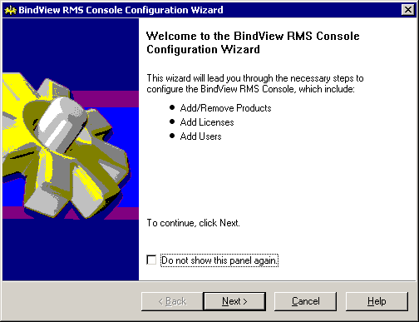
Start the Bindview RMS Application. When Bindview opens for the first time, the Configuration Wizard will start. You can also run the configuration from the RMS console shown below.

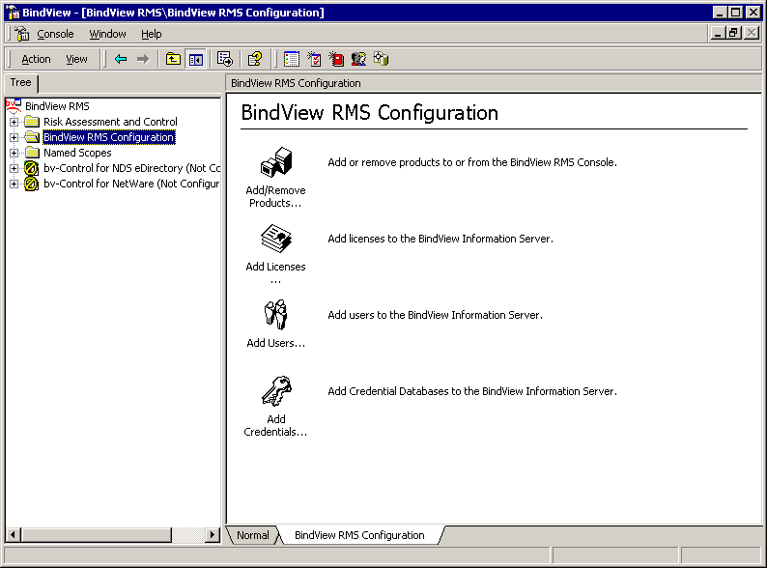

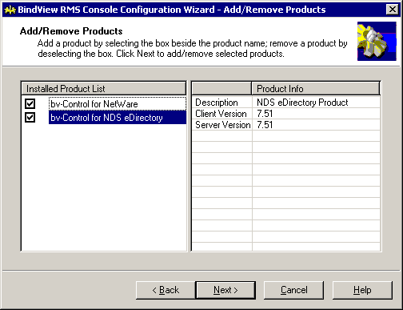

Add/Remove Products
Check the boxes for the installed product snap-ins

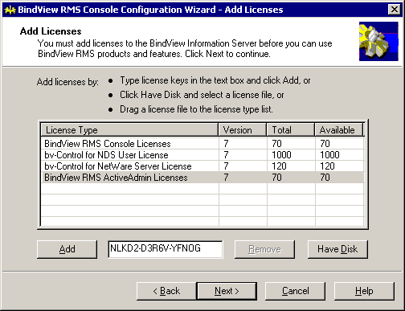

Add Licenses
Type in the license numbers for the products shown. Two of the products have changed names and are referred to with different names depending on the particular documentation.

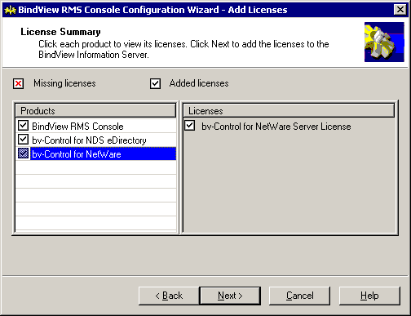
Bv-Control for NDS eDirectory may also called Bv-Control for NetWare and NDS User
bv-Control for NetWare may also called Bv-Control for NetWare and NDS Server

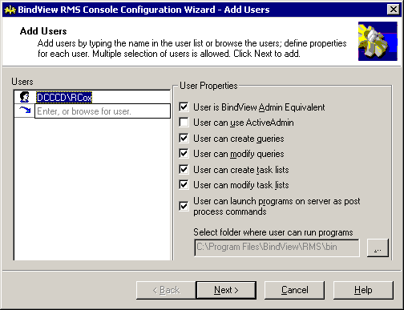

Add Users
Click on Enter, or browse for user. Make sure all of the boxes are checked
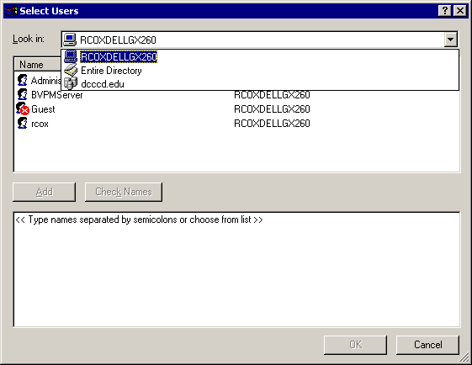
Browse the ADM domain to select your Windows Login ID
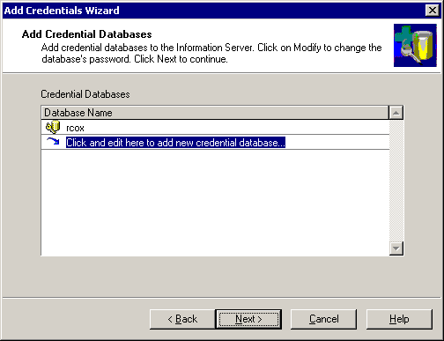

Add Credential Databases
In the Bindview RMS Configuration Window, click Add Credentials to add a new database. Use your Login name for the database name

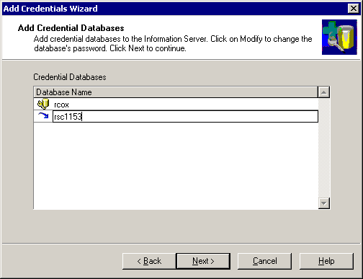
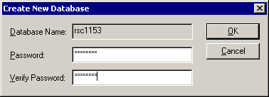
Use the same password as your login ID to avoid authentication problems

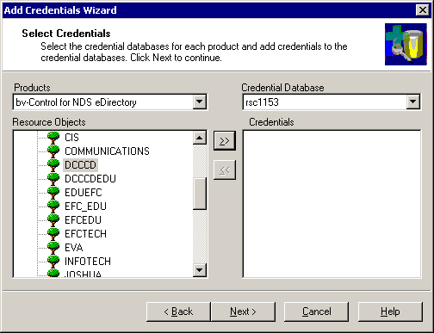
Select your NDS tree and context
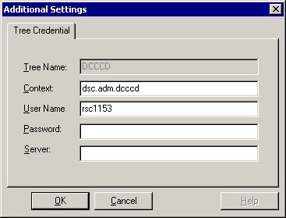
Log in to the NDS container

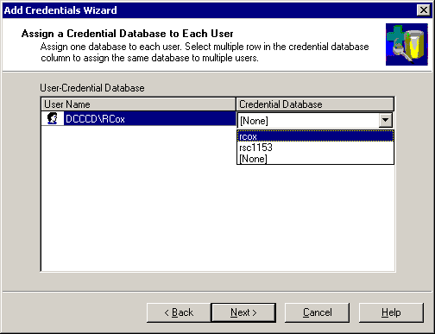
Assign the database to your user ID. You are now ready to use Bindview RMS.

