Bindview Netinventory Console Installation
http://netsupport.dcccd.edu/bindview.htm

Before starting the installation you should close all other programs.

Log in to the ADM domain, OR

Map a drive to the master server BVEMS share

In Windows Explorer select Tools\ Map Network Drive
choose an unused drive letter, and in the Folder box type in \\DSCBV1\BVEMS
check the “Reconnect at Login” box

Accounts in the ADM Domain are set up with your 3-letter 4-digit login ID, so you might also need to click on connect using a different user name.
Log in to the ADM domain with the domain name and your user name, for example:

User name: ADM\abc1234
Password: *******
Your password for the ADM domain may not be the same as your Novell password.

check the Reconnect at Logon box

2) Run the Bindview Console install

Go to the DSC2\SYS\INSTALL\Bindview\NetInventory\NETinventory Console folder

There are several Setup icons, Run Setup.exe (the icon that looks like a computer)

The first setup screen: “It is strongly recommended that you exit all Windows programs…..”
Click NEXT

License Agreement YES

Setup Type: Select Local Installation

Accept the default location C:\Bindview Click NEXT

If you already have Bindview installed you may get a pop-up message “An older version of Netinventory Console was found. Do you want to upgrade to the current version?”
Choose Yes

The next screen is a list of Bindview components. Check these two:
- NETinventory Console
- NETinventory Snap-in NEXT

Program Folder Bindview, Choose YES to create the folder if it does not exist

Next screen: Allow Bindview to update the system files:
MS 16bit, Ntwrk kit, netapi.dll NEXT

Files will be copied to your workstation. This should only take a minute to copy the files.

Setup has detected that you have a valid TZ (timezone) environment setting…. Do you want to review and modify this setting? click YES.

Time Zone: GMT-6 US Central
- Add this setting to the system’s (global profile)
NEXT

Check this box if you need to update the NETinventory licenses on this workstation:
- Add new Licenses for NETinventory Console now
NEXT

Uncheck the README files:
- Release Notes
- Install Log
NEXT

The License Manager screen will appear. If these licenses are not already listed, click Add, and insert the License Code Numbers from the BVlicense document,

DONE

STOP STOP STOP
If you get the window shown below, select CANCEL. This screen is for the Master Server installation. This has already been done and should not be run again.

At the next screen, shown below, click Cancel

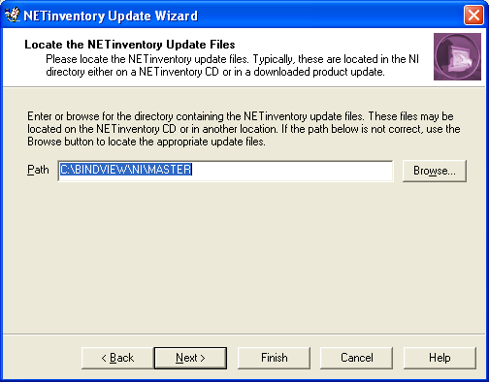

After installation is finished you should reboot your PC.

3) Configure the Netinventory console

Open the NETinventory Console
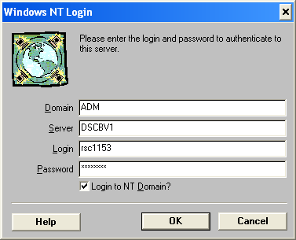
This is the ADM Domain login, use your ADM Login and password

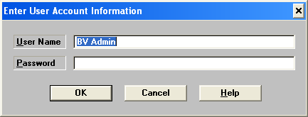
This is the NETinventory Console Login
Log in to the Netinventory Console as BV Admin with a blank password

When the NETinventory console is open:

Select Options from the menu bar at top of the page (not shown)

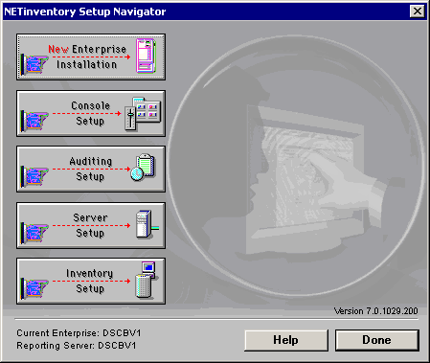
From the Options pull down menu select Netinventory Setup

Select Console Setup (shown above)

Select OK if you get a message “…Servers have not been configured…”

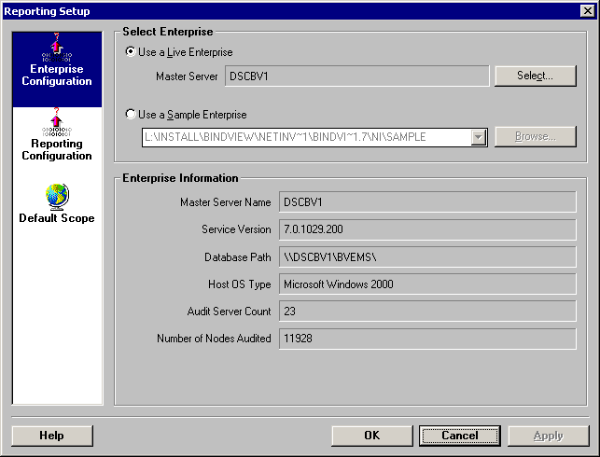
Make sure Enterprise Configuration is highlighted in the left column (shown above)

Click on the “Use a Live Enterprise” button

Click on Select

In the Select Server box type in DSCBV1

Click on the Windows NT button, and OK

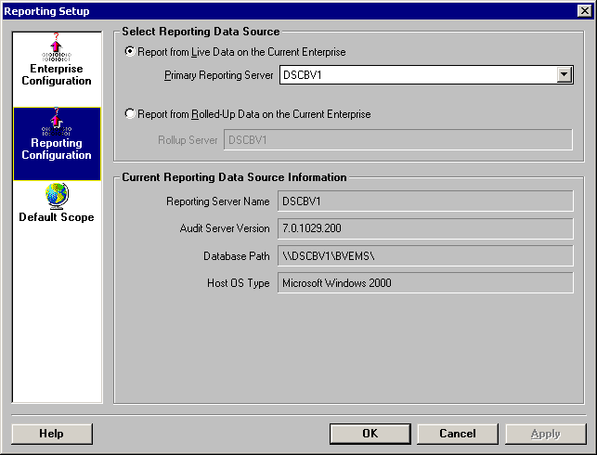
Click OK if you get the “Needs Upgrading” message

Click on Reporting Configuration in the left column

Click on “Report from Live Data on the Current Enterprise” button

From the Primary Reporting Server Pull-down list select DSCBV1

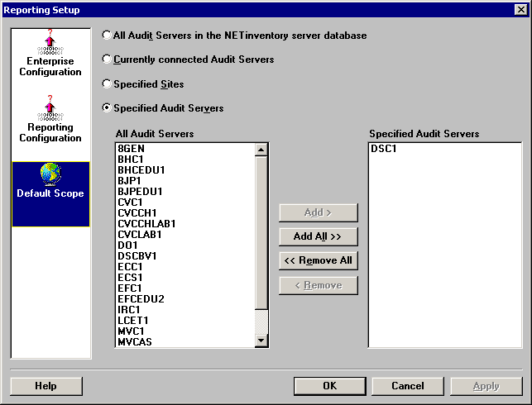
Click on Default Scope in the left column (shown above)

Select the Specified Audit Servers button

Add your local server from the list on the left to the Specified Audit Server list

Make sure that your server is the only one in the Specified Audit Server list on the right

Click Apply, then OK

You should now be able to run a Netinventory report.

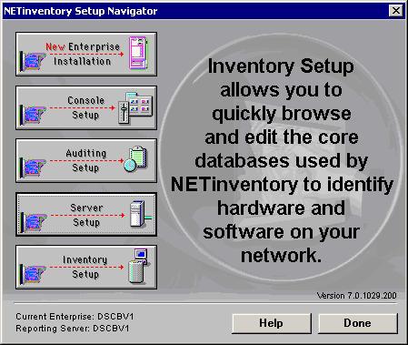
Console Setup is the only option on the Netinventory Setup Navigator window that you will need to use.
The other setup options such as Enterprise Setup, Auditing Setup, Server Setup, and Inventory Setup are already configured, and should not be changed. These settings affect servers and users district-wide.
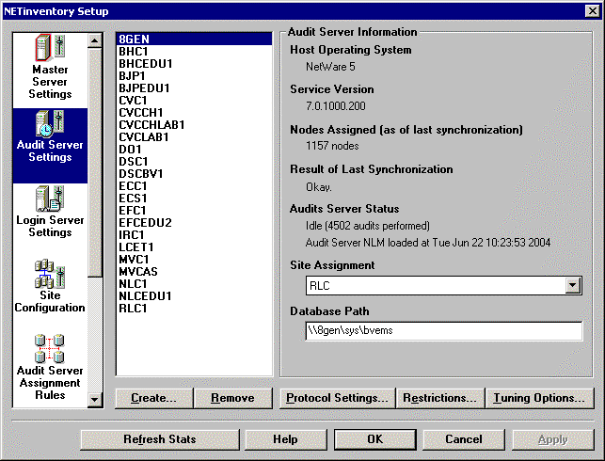 No configuration changes should be made in this window.
This example indicates that the 8GEN server is assigned to the RLC site.
It should not be moved to another site.

Add a License

From the Options menu, select Manage Licenses. The NETinventory License Manager dialog appears.

Click Add. The NETinventory License Installation dialog appears.

In the License Key field, enter the 15 character License Key number.

Click OK to install the license.

Importing Reports (see “Netinventory user Guide “ chapter 13, pg 310-311 for more details)

Exported grids and folders are saved as *.EXP files

In the Bindview console, highlight the folder tab where you want the imported grid to go

From the console select Desktop \ Import Item

Browse to the location where the *.EXP file is saved, highlight the *.EXP file, click OK

Exporting Reports

In the Bindview console, highlight the report that you want to export

From the console select Desktop \ Export Item

Browse to the location where you want the *.EXP file saved, type in a file name, click OK

